EWMA correlation: NZDUSD and EURGBP
Method 06 / daily log returns / lambda = 0.94 / Alpari D1 full available history

Study setup
Logical pair: NZDUSD , EURGBP
Broker symbols: NZDUSD_i , EURGBP_i
Snapshot: 2026-11-03_majors_alpari_D1
Timeframe: D1
Matched return window: 1999-01-06 to 2026-11-02 (UTC bar dates)
Matched return count n: 7183
Dropped unfinished last bar dated 2026-11-03 UTC after a tick-volume check against the prior complete day.
Lambda: 0.94 (today weight 0.06)
Burn-in ignored in path summaries and chart: first 60 updates
Mean adjustment: each leg demeaned by its mean on the matched rows
Seeds: c_0 = v_x,0 = v_y,0 = 0
Complete matched rows (Excel): NZDUSD-EURGBP_EWMA_D1.xlsx
Complete matched rows (HTML table): NZDUSD-EURGBP_EWMA_D1_data.html

Method carried forward
EWMA correlation updates covariance and variances of mean-adjusted daily log returns of close, ln(close_t / close_t-1), with lambda = 0.94 (6% weight on today's product or square, 94% on yesterday's EWMA state). Quotes are not inverted. Each leg is demeaned by its mean on the matched rows; that mean uses the full sample, so the rho path is a full-sample description, not a live filter. Seeds start at zero. Path summaries and the chart ignore the first 60 updates so the zero seed has faded. The headline is rho on the last day. rho is symmetric under swap of the two symbols. A high |rho| does not prove cause, lead-lag, or a trading signal. Today's return sits inside today's rho, so the estimate can only inform a later decision. Same-sample Pearson r is a side check only.

Results
Latest EWMA rho: -0.162548
Post-burn-in path (n=7123): mean=0.034295, median=0.030143, min=-0.777740, max=0.719825, std=0.253645
Share of post-burn-in days with |rho| >= 0.4: 14.04%; |rho| >= 0.7: 0.07%
Same-sample Pearson r: 0.037186
Latest rho minus r: -0.199735

Conclusion
Over 7183 matched daily log-return rows for NZDUSD and EURGBP (broker quote directions unchanged), latest EWMA rho with lambda=0.94 is -0.1625 (negative, weak recent linear link in this sample). After a 60-day burn-in, path mean is 0.0343, std is 0.2536, and the range is [-0.7777, 0.7198]. Same-sample Pearson r is 0.0372 (latest rho minus r = -0.1997). This does not establish cause, lead-lag, or a lasting trading rule.

Charts
Daily closes

Daily log returns
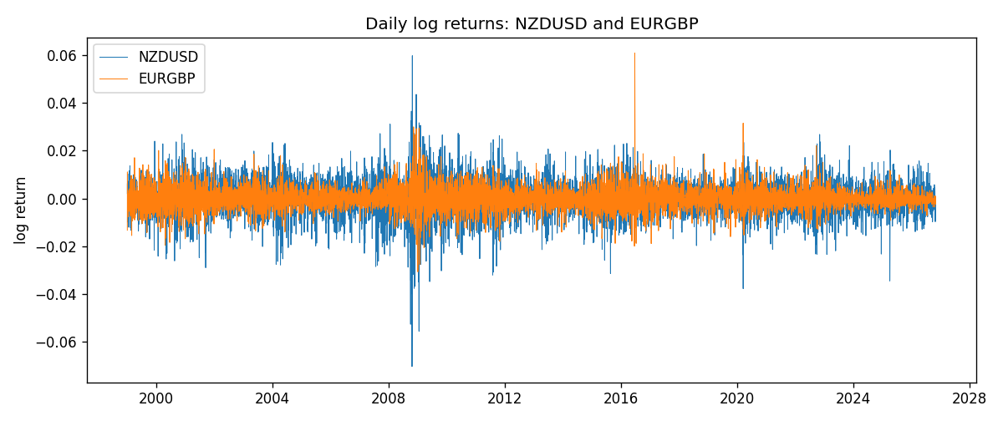
EWMA rho path with Pearson r reference
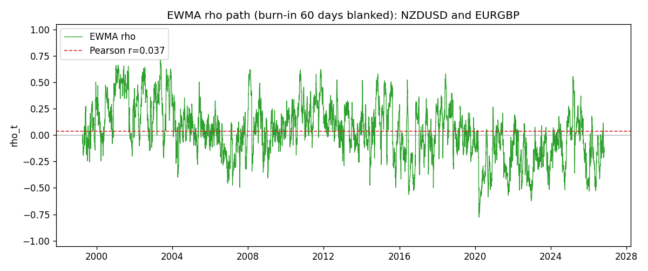

Data report
Every matched row that entered the EWMA recursion is stored in the sibling Excel workbook named NZDUSD-EURGBP_EWMA_D1.xlsx. That file is the complete data archive for redrawing charts. Embedding all rows as a Word table is impractical at this length; the Word file holds the column list, column summaries, and the first and last 15 matched rows.
Columns: time, NZDUSD_open, EURGBP_open, NZDUSD_high, EURGBP_high, NZDUSD_low, EURGBP_low, NZDUSD_close, EURGBP_close, NZDUSD_tick_volume, EURGBP_tick_volume, NZDUSD_spread, EURGBP_spread, NZDUSD_real_volume, EURGBP_real_volume, NZDUSD_log_return, EURGBP_log_return, NZDUSD_x_demeaned, EURGBP_y_demeaned, c_t, v_x, v_y, rho_t
Column summaries (matched calculation rows)
column | count | mean | std | min | 25% | 50% | 75% | max
NZDUSD_open | 7183 | 0.65646991 | 0.10818219 | 0.3913 | 0.591455 | 0.6684 | 0.72495 | 0.88218
EURGBP_open | 7183 | 0.78694248 | 0.0966971 | 0.5734 | 0.68755 | 0.83389 | 0.86522 | 0.9769
NZDUSD_high | 7183 | 0.66038812 | 0.10867344 | 0.3961 | 0.5949 | 0.67204 | 0.729365 | 0.88421
EURGBP_high | 7183 | 0.7900202 | 0.09707133 | 0.5789 | 0.6896 | 0.8369 | 0.8681 | 0.9799
NZDUSD_low | 7183 | 0.65278196 | 0.10777661 | 0.3897 | 0.58816 | 0.6642 | 0.720985 | 0.87988
EURGBP_low | 7183 | 0.78424251 | 0.0965143 | 0.5682 | 0.6855 | 0.83166 | 0.86287 | 0.9661
NZDUSD_close | 7183 | 0.65654354 | 0.10817679 | 0.3907 | 0.59181 | 0.6685 | 0.72502 | 0.8822
EURGBP_close | 7183 | 0.78698724 | 0.09669475 | 0.5735 | 0.68775 | 0.83395 | 0.86536 | 0.977
NZDUSD_tick_volume | 7183 | 68736.568 | 123152.54 | 16 | 5594.5 | 33901 | 58513.5 | 1127682
EURGBP_tick_volume | 7183 | 87133.158 | 145499.84 | 154 | 6553 | 44358 | 81413 | 1424684
NZDUSD_spread | 7183 | 30.260755 | 25.633067 | 0 | 9 | 17 | 40 | 80
EURGBP_spread | 7183 | 21.328832 | 19.122264 | 0 | 4 | 13 | 40 | 50
NZDUSD_real_volume | 7183 | 1.6708354e+10 | 8.49951e+10 | 0 | 0 | 0 | 0 | 2.705649e+12
EURGBP_real_volume | 7183 | 2.7872287e+10 | 1.3521454e+11 | 0 | 0 | 0 | 0 | 3.5726265e+12
NZDUSD_log_return | 7183 | 1.073e-05 | 0.0076464 | -0.07027433 | -0.00425909 | 0.00022967 | 0.00458236 | 0.05966839
EURGBP_log_return | 7183 | 2.33e-05 | 0.00487088 | -0.03067367 | -0.00262163 | -9.879e-05 | 0.002558 | 0.06075387
NZDUSD_x_demeaned | 7183 | -0 | 0.0076464 | -0.07028506 | -0.00426982 | 0.00021893 | 0.00457162 | 0.05965766
EURGBP_y_demeaned | 7183 | -0 | 0.00487088 | -0.03069697 | -0.00264493 | -0.00012209 | 0.0025347 | 0.06073057
c_t | 7183 | 1.39e-06 | 1.265e-05 | -0.00012983 | -2.9e-06 | 6.9e-07 | 6.21e-06 | 5.582e-05
v_x | 7183 | 5.842e-05 | 5.9e-05 | 2.5e-07 | 3.043e-05 | 4.244e-05 | 6.69e-05 | 0.00086271
v_y | 7183 | 2.372e-05 | 2.336e-05 | 1.89e-06 | 1.049e-05 | 1.822e-05 | 3.005e-05 | 0.00029341
rho_t | 7183 | 0.03386206 | 0.25329069 | -1 | -0.12592767 | 0.03006456 | 0.19635089 | 0.71982467
First 15 matched rows (selected columns)
time | NZDUSD_close | EURGBP_close | NZDUSD_log_return | EURGBP_log_return | NZDUSD_x_demeaned | EURGBP_y_demeaned | c_t | v_x | v_y | rho_t
1999-01-06 | 0.5383 | 0.7019 | 0.0020455609 | -0.013303338 | 0.0020348282 | -0.013326637 | -1.6270451e-06 | 2.4843155e-07 | 1.0655956e-05 | -1
1999-01-07 | 0.5417 | 0.7097 | 0.0062963171 | 0.011051402 | 0.0062855844 | 0.011028102 | 2.6296617e-06 | 2.6040399e-06 | 1.7313741e-05 | 0.39163419
1999-01-08 | 0.5414 | 0.7062 | -0.00055396548 | -0.004943862 | -0.0005646982 | -0.0049671615 | 2.6401788e-06 | 2.4669306e-06 | 1.7755278e-05 | 0.39892489
1999-01-11 | 0.547 | 0.7053 | 0.010290425 | -0.0012752393 | 0.010279693 | -0.0012985388 | 1.6808533e-06 | 8.6592394e-06 | 1.6791134e-05 | 0.13939588
1999-01-12 | 0.5441 | 0.7077 | -0.0053157489 | 0.0033970309 | -0.0053264816 | 0.0033737314 | 5.0179504e-07 | 9.8419695e-06 | 1.6466589e-05 | 0.039416997
1999-01-13 | 0.5387 | 0.708 | -0.0099742238 | 0.00042381861 | -0.0099849565 | 0.00040051913 | 2.3173737e-07 | 1.5233413e-05 | 1.5488219e-05 | 0.015086786
1999-01-14 | 0.5386 | 0.7066 | -0.00018564931 | -0.0019793588 | -0.00019638202 | -0.0020026583 | 2.414303e-07 | 1.4321722e-05 | 1.4799564e-05 | 0.016583251
1999-01-15 | 0.5382 | 0.7012 | -0.00074294208 | -0.0076715819 | -0.0007536748 | -0.0076948814 | 5.7491077e-07 | 1.34965e-05 | 1.7464262e-05 | 0.037446802
1999-01-18 | 0.5372 | 0.7017 | -0.0018597736 | 0.00071280921 | -0.0018705064 | 0.00068950973 | 4.6303218e-07 | 1.2896638e-05 | 1.6444932e-05 | 0.031794858
1999-01-19 | 0.5382 | 0.7007 | 0.0018597736 | -0.0014261269 | 0.0018490409 | -0.0014494264 | 2.7444733e-07 | 1.2327977e-05 | 1.5584286e-05 | 0.019800203
1999-01-20 | 0.5404 | 0.7021 | 0.0040793678 | 0.0019960086 | 0.0040686351 | 0.0019727092 | 7.3955451e-07 | 1.2581526e-05 | 1.4882724e-05 | 0.054045847
1999-01-21 | 0.5426 | 0.7016 | 0.0040627941 | -0.00071240297 | 0.0040520614 | -0.00073570245 | 5.1631455e-07 | 1.2811786e-05 | 1.4022236e-05 | 0.038521296
1999-01-22 | 0.5361 | 0.7004 | -0.012051689 | -0.0017118406 | -0.012062422 | -0.0017351401 | 1.7411352e-06 | 2.0773201e-05 | 1.3361545e-05 | 0.1045087
1999-01-25 | 0.5342 | 0.6966 | -0.0035504102 | -0.0054402425 | -0.0035611429 | -0.005463542 | 2.8040543e-06 | 2.0287713e-05 | 1.4350869e-05 | 0.16433527
1999-01-26 | 0.5381 | 0.6962 | 0.0072741158 | -0.00057438255 | 0.0072633831 | -0.00059768204 | 2.3753395e-06 | 2.2235854e-05 | 1.3511251e-05 | 0.13704115
Last 15 matched rows (selected columns)
time | NZDUSD_close | EURGBP_close | NZDUSD_log_return | EURGBP_log_return | NZDUSD_x_demeaned | EURGBP_y_demeaned | c_t | v_x | v_y | rho_t
2026-10-13 | 0.56127 | 0.84458 | 0.0047326165 | 0.00020130374 | 0.0047218838 | 0.00017800426 | 7.755443e-07 | 1.6968179e-05 | 2.6769819e-06 | 0.1150711
2026-10-14 | 0.55918 | 0.84553 | -0.0037306483 | 0.0011241873 | -0.003741381 | 0.0011008878 | 4.818812e-07 | 1.6789964e-05 | 2.5890803e-06 | 0.073087371
2026-10-15 | 0.56185 | 0.84479 | 0.0047634855 | -0.00087557391 | 0.0047527527 | -0.00089887339 | 1.9664094e-07 | 1.7137886e-05 | 2.4822138e-06 | 0.030149196
2026-10-16 | 0.56509 | 0.84307 | 0.0057501001 | -0.0020380844 | 0.0057393674 | -0.0020613839 | -5.2501989e-07 | 1.8086033e-05 | 2.5882392e-06 | -0.076736483
2026-10-19 | 0.56616 | 0.84259 | 0.0018917133 | -0.00056950988 | 0.0018809806 | -0.00059280936 | -5.6042247e-07 | 1.7213156e-05 | 2.4540303e-06 | -0.086227408
2026-10-20 | 0.56827 | 0.83957 | 0.0037199341 | -0.0035906254 | 0.0037092014 | -0.0036139249 | -1.3310836e-06 | 1.7005857e-05 | 3.0904156e-06 | -0.18361055
2026-10-21 | 0.57003 | 0.83839 | 0.0030923331 | -0.00140647 | 0.0030816004 | -0.0014297695 | -1.5155773e-06 | 1.6555282e-05 | 3.0276452e-06 | -0.21407075
2026-10-22 | 0.56815 | 0.83682 | -0.0033035227 | -0.0018743924 | -0.0033142554 | -0.0018976919 | -1.0472765e-06 | 1.6221022e-05 | 3.0620605e-06 | -0.14859883
2026-10-23 | 0.56991 | 0.83751 | 0.0030929853 | 0.00082421033 | 0.0030822525 | 0.00080091085 | -8.3632339e-07 | 1.5817778e-05 | 2.9168244e-06 | -0.12312504
2026-10-26 | 0.56826 | 0.83762 | -0.0028993932 | 0.00013133309 | -0.0029101259 | 0.00010803361 | -8.0500747e-07 | 1.5376841e-05 | 2.7425152e-06 | -0.12396293
2026-10-27 | 0.56811 | 0.83595 | -0.00026399852 | -0.0019957343 | -0.00027473124 | -0.0020190338 | -7.2342552e-07 | 1.4458759e-05 | 2.8225541e-06 | -0.11324191
2026-10-28 | 0.56261 | 0.83651 | -0.0097283914 | 0.00066967224 | -0.0097391241 | 0.00064637276 | -1.0577263e-06 | 1.9282266e-05 | 2.6782687e-06 | -0.14718623
2026-10-29 | 0.56296 | 0.83553 | 0.00062190714 | -0.0011722209 | 0.00061117443 | -0.0011955204 | -1.038103e-06 | 1.8147742e-05 | 2.6033288e-06 | -0.15103049
2026-10-30 | 0.56307 | 0.83351 | 0.00019537668 | -0.0024205543 | 0.00018464396 | -0.0024438538 | -1.0028914e-06 | 1.7060923e-05 | 2.8054743e-06 | -0.14496044
2026-11-02 | 0.56161 | 0.83426 | -0.0025962955 | 0.00089940465 | -0.0026070282 | 0.00087610517 | -1.0797597e-06 | 1.6445063e-05 | 2.6831995e-06 | -0.16254847

